Spotkanie z sędzią sportowym
Ukazywanie autorytetów

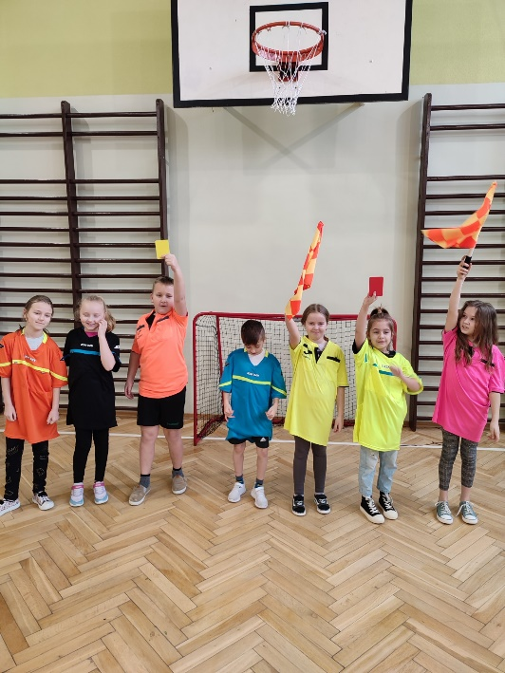
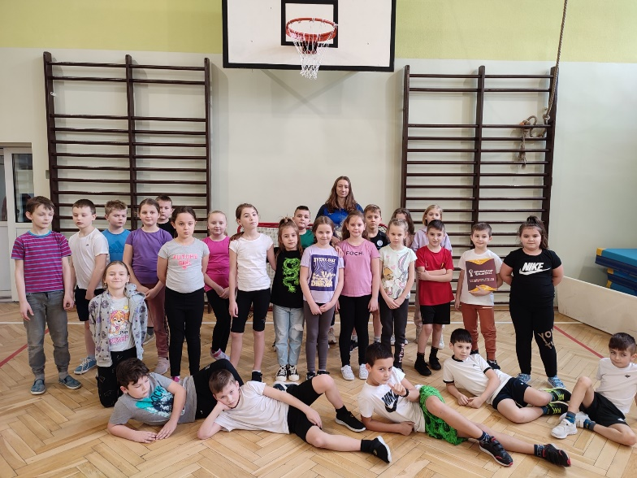

https://spborowa.edupage.org/news/?eqa=d2lkPW5ld3NfTmV3c18xX3AmbmV3c2FyY2hpdmVmPTIwMjMtMDMmb2Zmc2V0X25ld3NfTmV3c18xX3A9MjA%3D#photos:album:1962

HASZTASZKI na Mistrzostwach Województwa Podkarpackiego w Boksie Olimpijskim!
Promowanie uczniowskich talentów

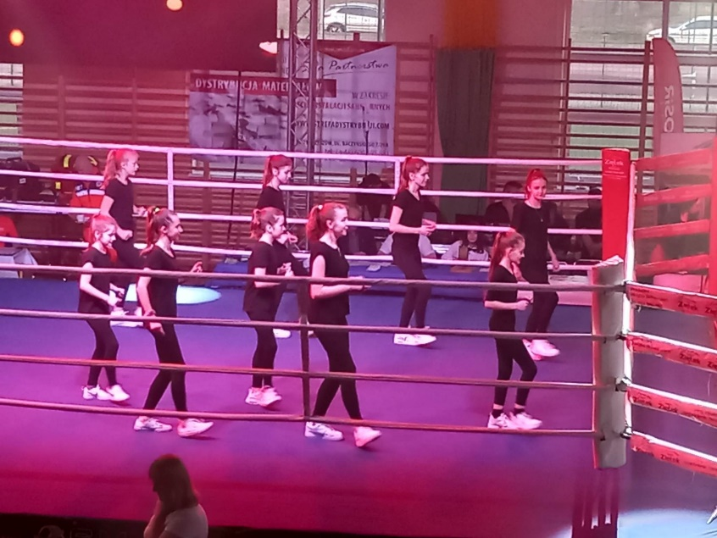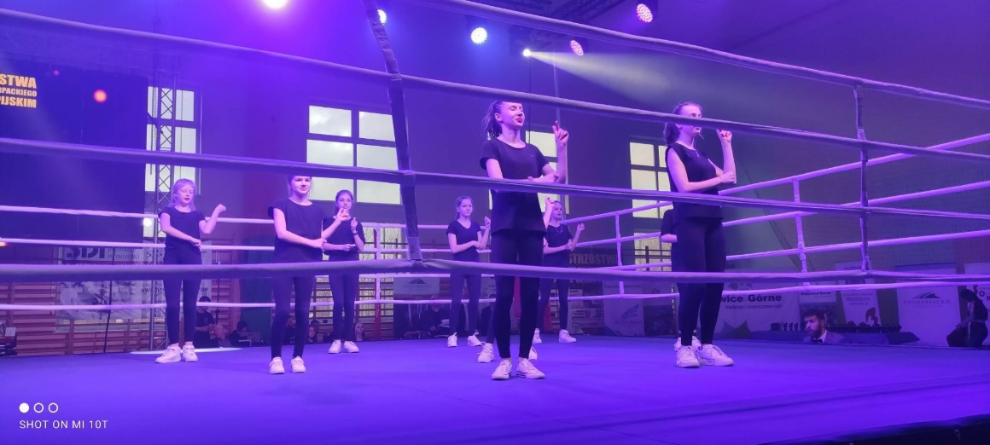

pborowa.edupage.org/news/?eqa=d2lkPW5ld3NfTmV3c18xX3AmbmV3c2FyY2hpdmVmPTIwMjMtMDMmb2Zmc2V0X25ld3NfTmV3c18xX3A9MjA%3D#photos:album:1966

„Świat widziany przez alkogogle i narkogogle”
Profilaktyka uzależnień

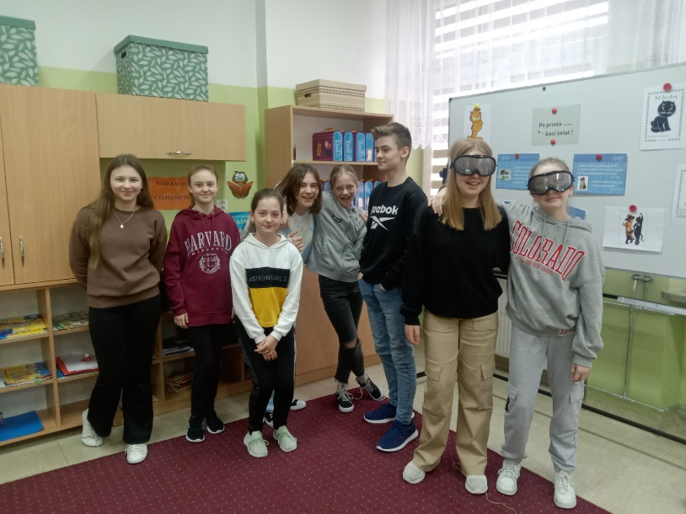

https://spborowa.edupage.org/news/?eqa=d2lkPW5ld3NfTmV3c18xX3AmbmV3c2FyY2hpdmVmPTIwMjMtMDMmb2Zmc2V0X25ld3NfTmV3c18xX3A9MjA%3D#photos:album:1961
„Tydzień dla zdrowia psychicznego”

Dbanie o prawidłowy rozwój psychiczny

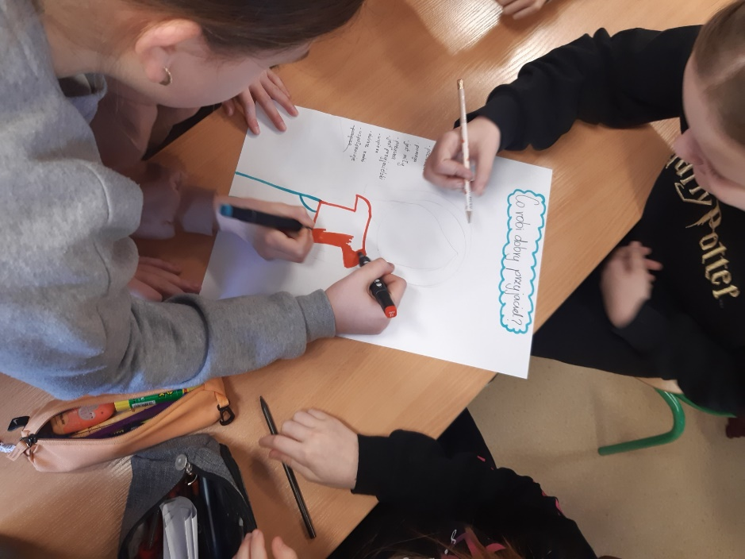
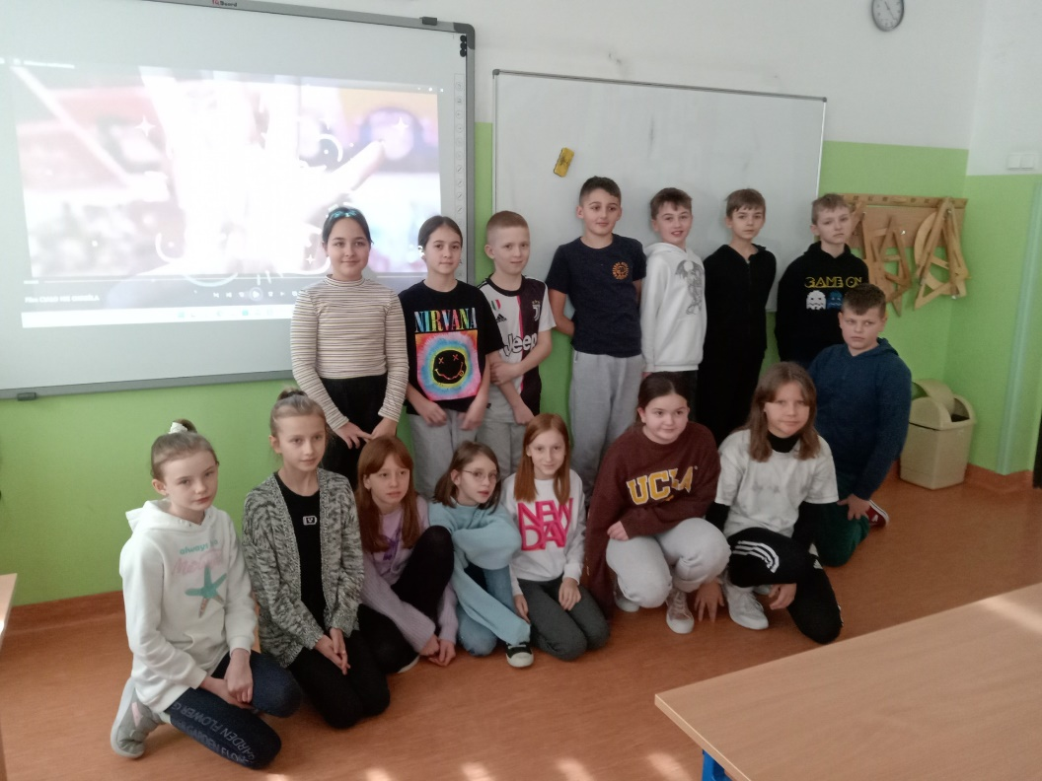

https://spborowa.edupage.org/news/?eqa=d2lkPW5ld3NfTmV3c18xX3AmbmV3c2FyY2hpdmVmPTIwMjMtMDMmb2Zmc2V0X25ld3NfTmV3c18xX3A9MjA%3D#photos:album:1967

"O zdrowym żywieniu słów kilka" - wykłady prowadzone przez dr Dorotę Nowak
Promowanie zdrowia
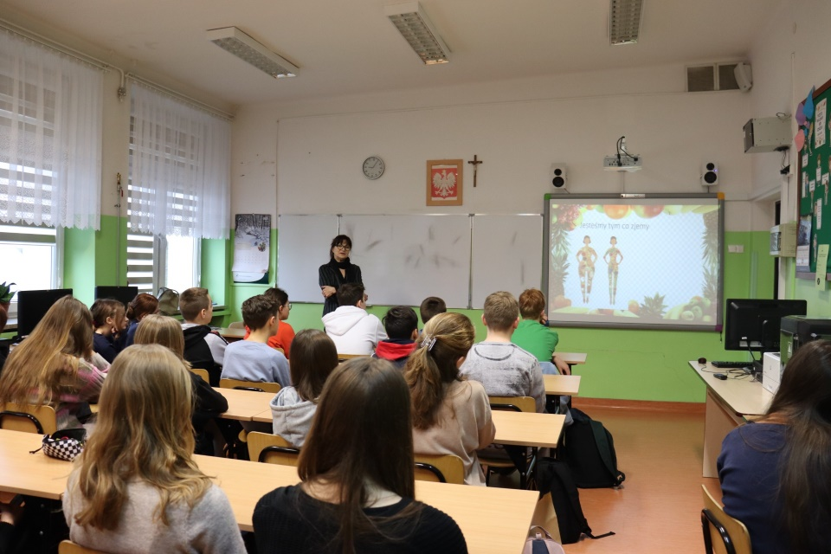
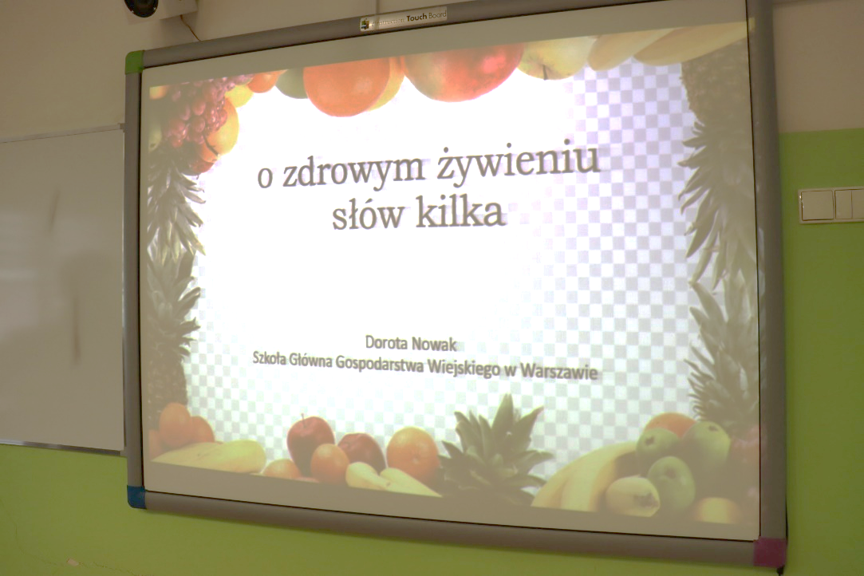

https://spborowa.edupage.org/news/?eqa=d2lkPW5ld3NfTmV3c18xX3AmbmV3c2FyY2hpdmVmPTIwMjMtMDMmb2Zmc2V0X25ld3NfTmV3c18xX3A9MjA%3D#photos:album:1968

Dzień kobiet w przedszkolu

Kultywowanie tradycji

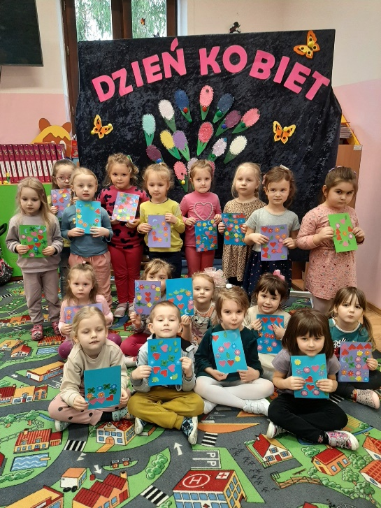
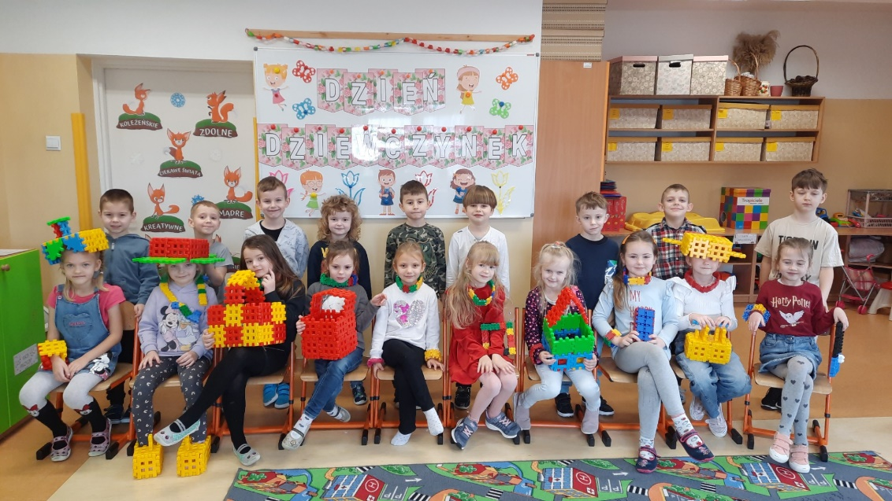

https://spborowa.edupage.org/news/?eqa=d2lkPW5ld3NfTmV3c18xX3AmbmV3c2FyY2hpdmVmPTIwMjMtMDMmb2Zmc2V0X25ld3NfTmV3c18xX3A9MA%3D%3D#photos:album:1969
Warsztaty kulinarne w klasie III a

Promowanie zdrowego stylu życia

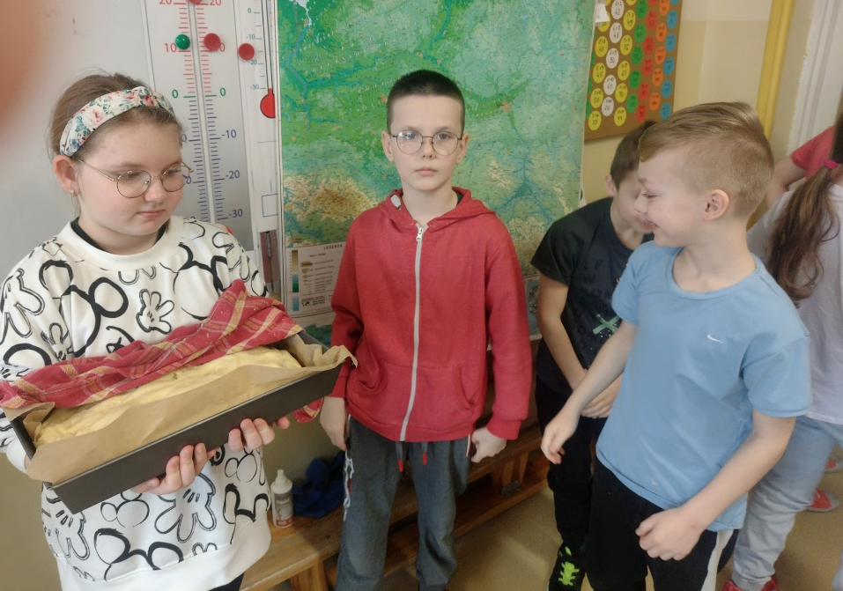
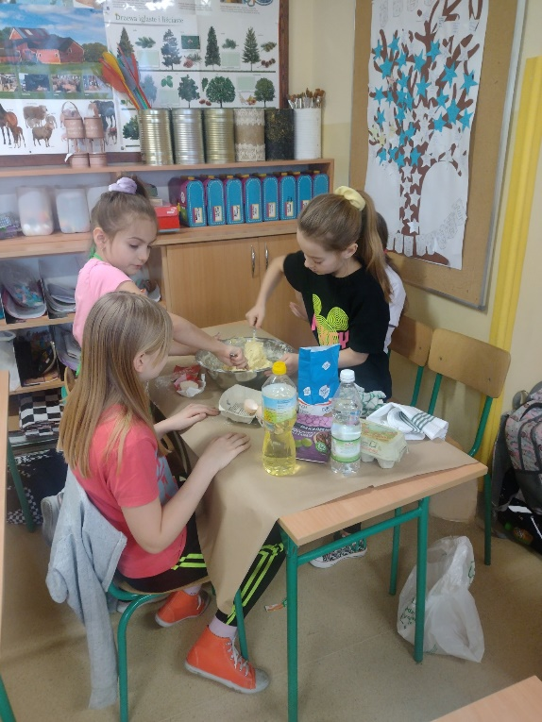

https://spborowa.edupage.org/news/?eqa=d2lkPW5ld3NfTmV3c18xX3AmbmV3c2FyY2hpdmVmPTIwMjMtMDMmb2Zmc2V0X25ld3NfTmV3c18xX3A9MA%3D%3D#photos:album:1973

Dzień kolorowej skarpetki

Nauka tolerancji i szacunku do drugiego człowieka

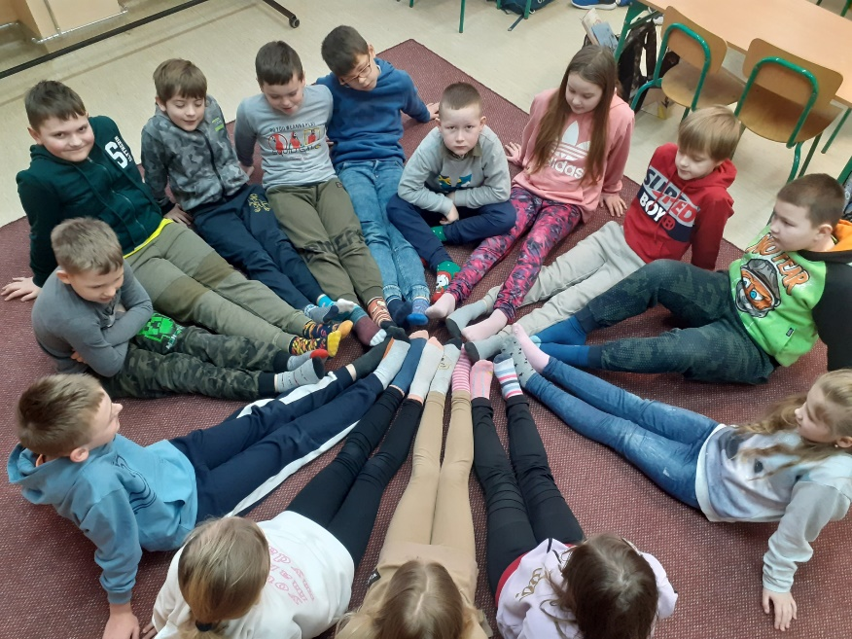
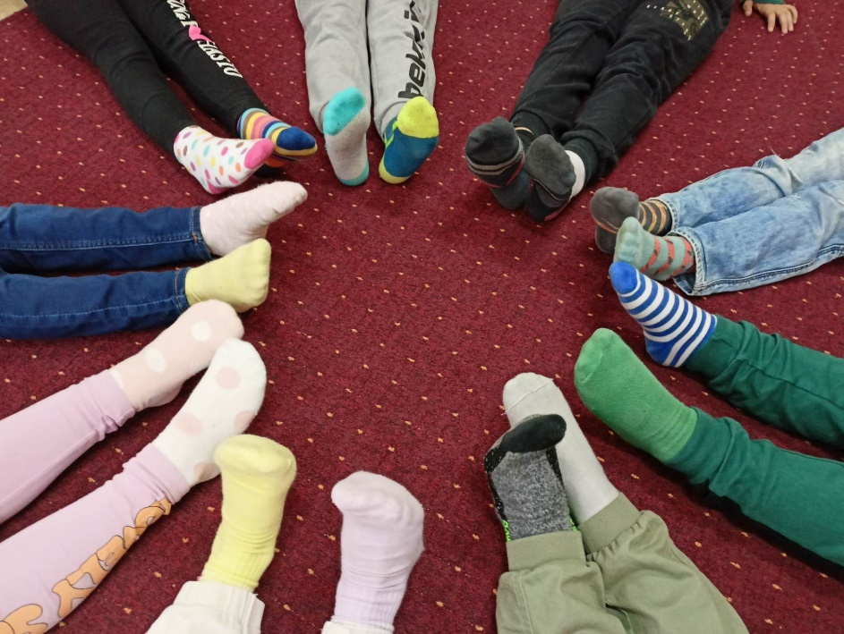

https://spborowa.edupage.org/news/?eqa=d2lkPW5ld3NfTmV3c18xX3AmbmV3c2FyY2hpdmVmPTIwMjMtMDMmb2Zmc2V0X25ld3NfTmV3c18xX3A9MA%3D%3D#photos:album:1976
Projekt „Agresja w sieci” w klasie 6 b

Budowanie właściwych postaw

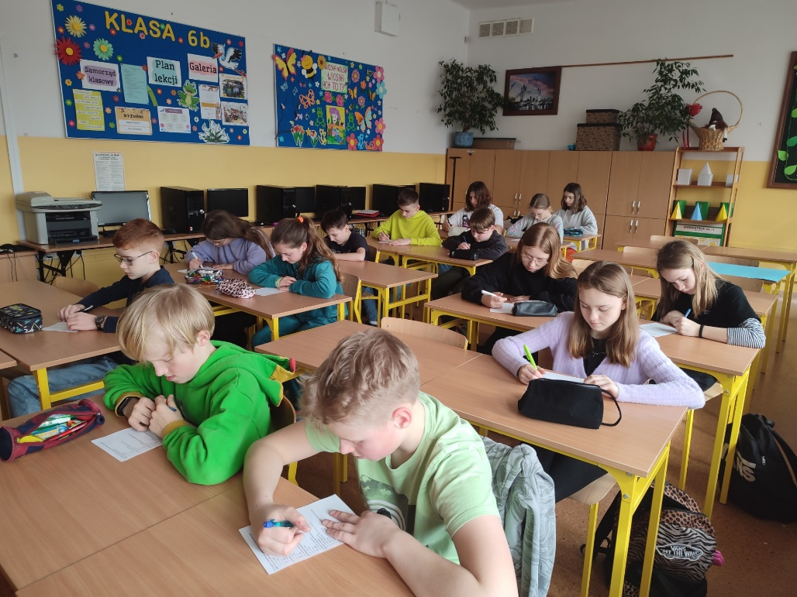
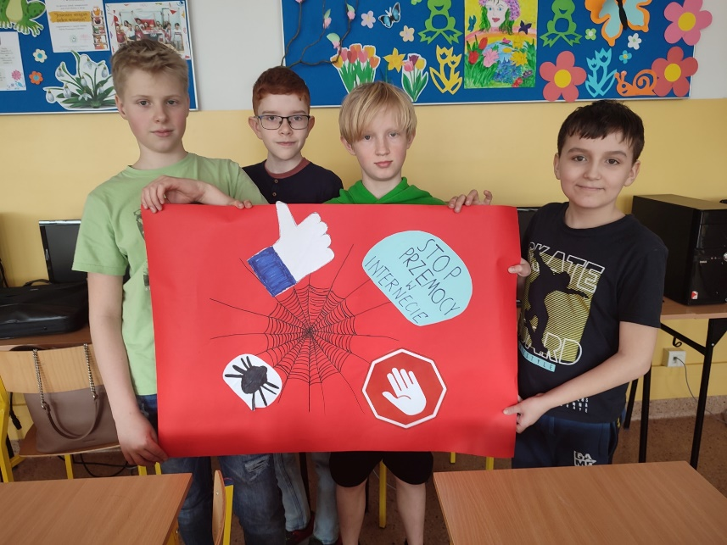

https://spborowa.edupage.org/news/?eqa=d2lkPW5ld3NfTmV3c18xX3AmbmV3c2FyY2hpdmVmPTIwMjMtMDMmb2Zmc2V0X25ld3NfTmV3c18xX3A9MA%3D%3D#photos:album:1977

Pierwszy dzień wiosny na sportowo

Kształtowanie ducha sportu

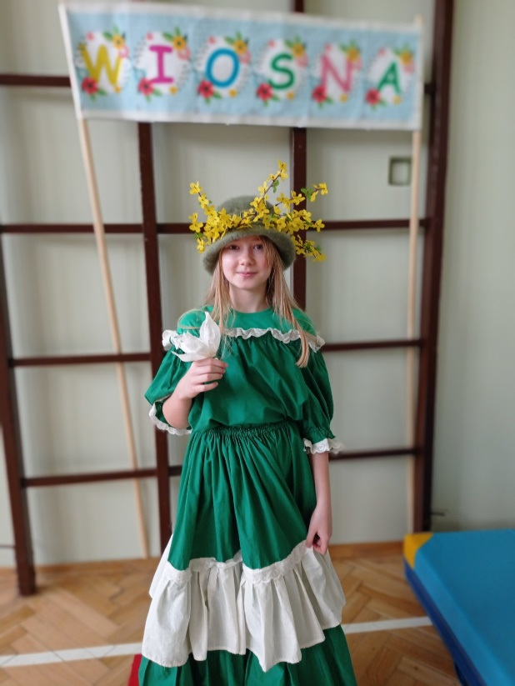
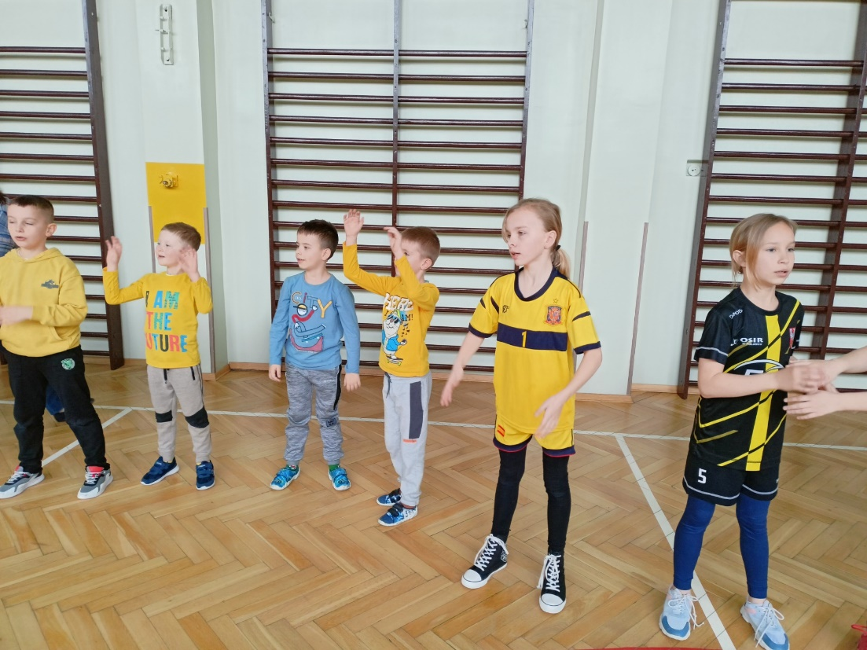

https://spborowa.edupage.org/news/?eqa=d2lkPW5ld3NfTmV3c18xX3AmbmV3c2FyY2hpdmVmPTIwMjMtMDMmb2Zmc2V0X25ld3NfTmV3c18xX3A9MA%3D%3D#photos:album:1979

Wyjazd przedszkolaków do SCK w Mielcu, na spektakl pt.: " Ach, ta Pippi"

Promowanie różnych form spędzania wolnego czasu

Kształtowanie ducha sportu

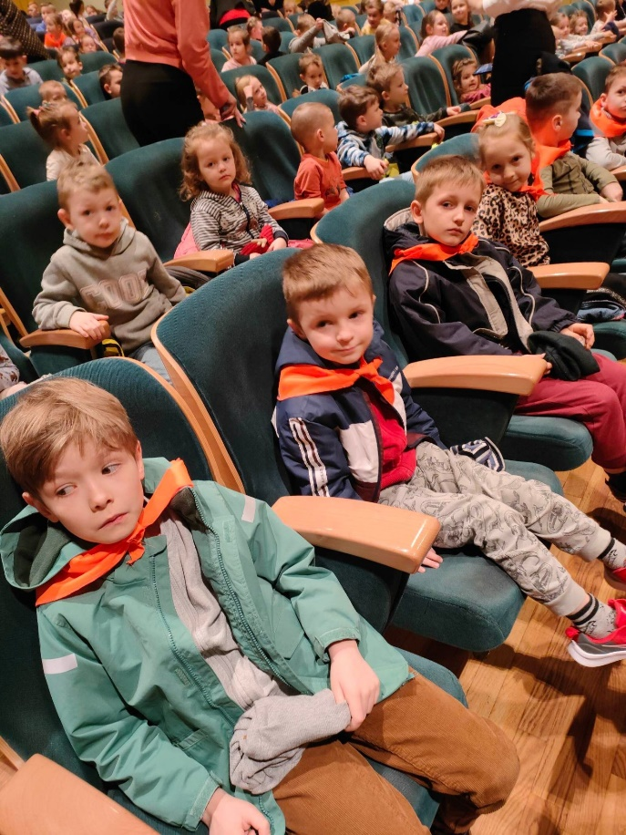

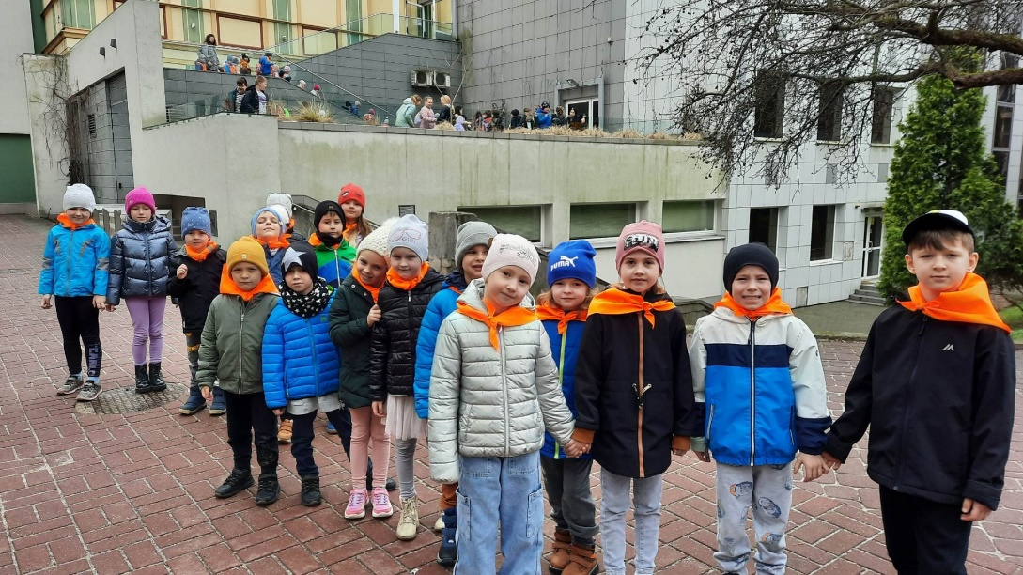

https://spborowa.edupage.org/news/?eqa=d2lkPW5ld3NfTmV3c18xX3AmbmV3c2FyY2hpdmVmPTIwMjMtMDMmb2Zmc2V0X25ld3NfTmV3c18xX3A9MA%3D%3D#photos:album:1980

Światowy Dzień Wody w grupie "Jeżyków"
Kształtowanie postawy odpowiedzialności za środowisko

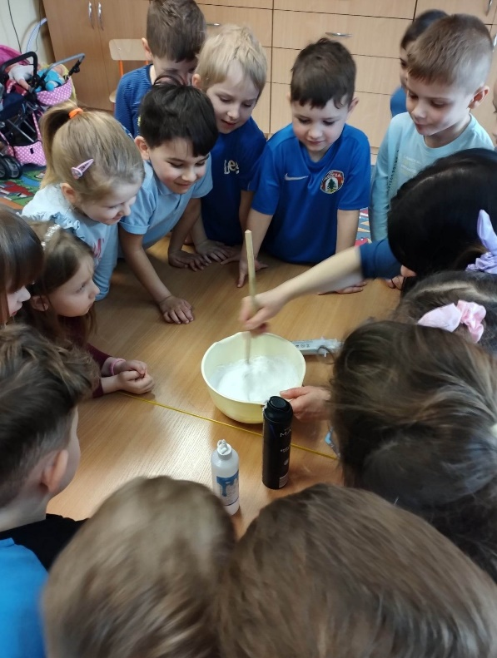
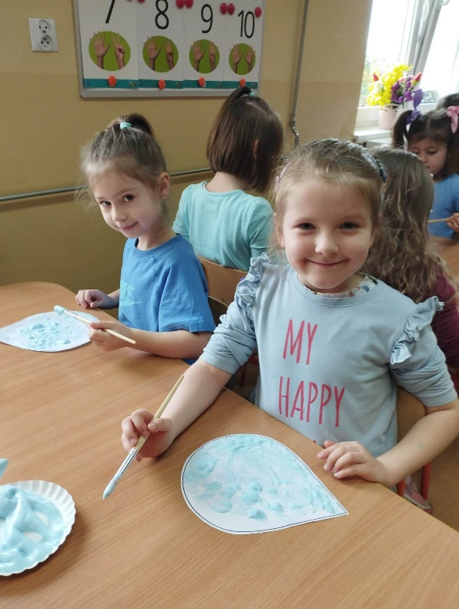

https://spborowa.edupage.org/news/?eqa=d2lkPW5ld3NfTmV3c18xX3AmbmV3c2FyY2hpdmVmPTIwMjMtMDMmb2Zmc2V0X25ld3NfTmV3c18xX3A9MA%3D%3D#photos:album:1982

Powitanie wiosny
Integracja zespołów

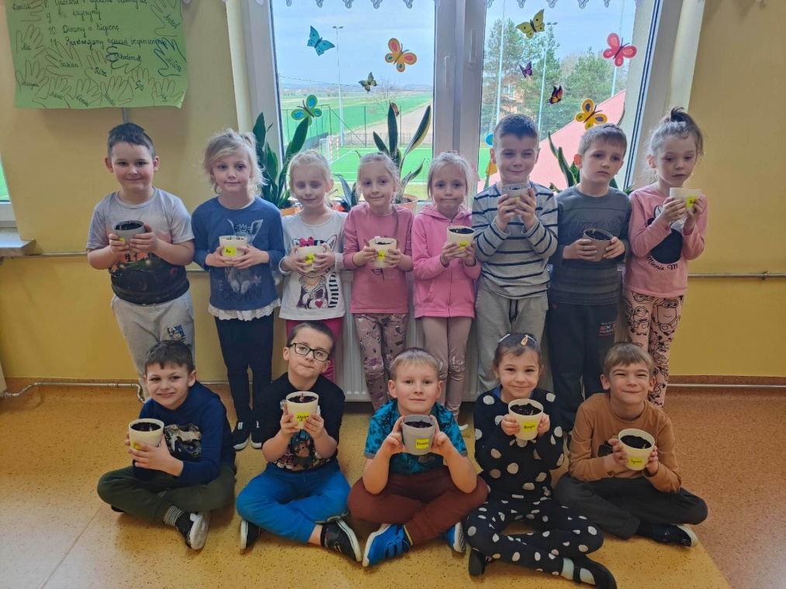
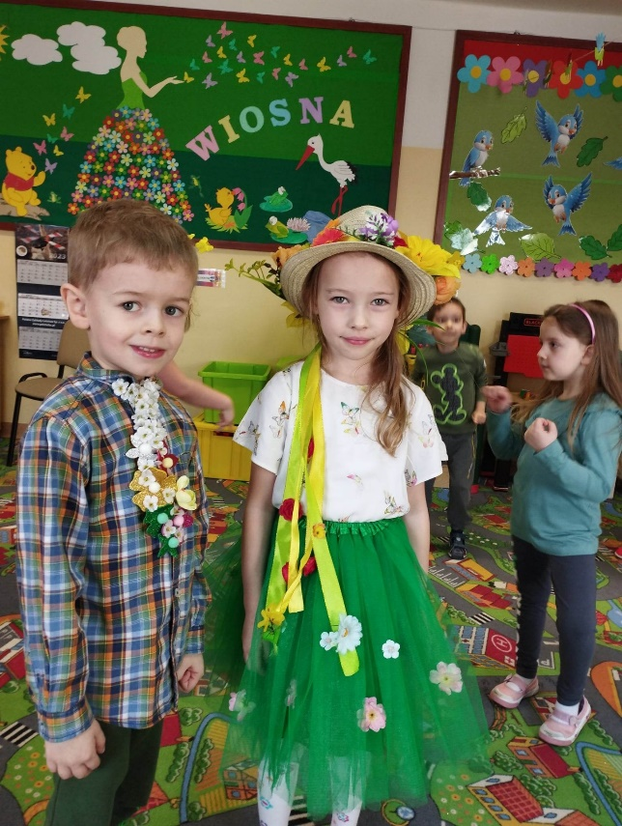

https://spborowa.edupage.org/news/?eqa=bmV3c2FyY2hpdmVmPTIwMjMtMDM%3D#photos:album:1991

