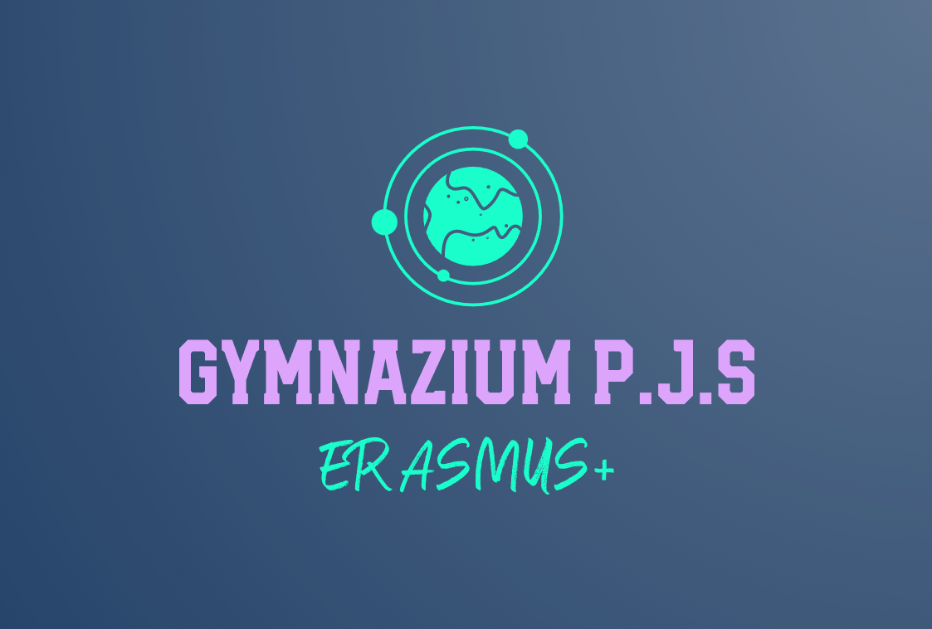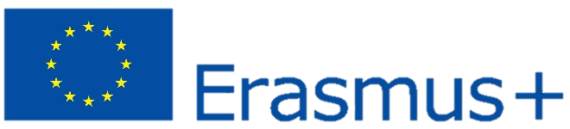

Contribute to education for more active citizenship among young people in society.

Deepen knowledge of sustainable development at local, national and international levels.

Improving and enrinching the competence profile of teachers, as well as inecereasing the professionalization of teachers in the field of applying inter-subject relations through the use of foreign languages.

School internationalization and cultural identity in a multicultural European environment.